|  |  |  |  |
| --- | --- | --- | --- |
| **Document** | **5DH_HowToCreateFlashPack** | | |
|  |  |  |  |
|  |  |  |  |



**5DH_HowToCreateFlashPack**

***SVN Path :***

[https://desoeap16.delta.corp/svn/STEP1M_auto_renault/branches/DES_SWEET400_FBL_Base_22_26_00/45_Appl_Tools](https://desoeap16.delta.corp/svn/STEP1M_auto_renault/branches/DES_SWEET400_FBL_Base_22_26_00/45_Appl_Tools/15_FlashContainer_DiagH)

Contents

program the FBL to the controller 3

program the LvController: 3

program the HvController 4

How to Change the Version of Appl SW 5

How to create VflashPack for Application SW 5

How to create PDX 10

“How to flash with vflash 12

Release the APPL SW 12

How To Set SaSrv Mode To FVIRGIN 14

# program the FBL to the controller

* Flash Desired FBL SW in Both HV and LV Controller
* refer the steps to How To flash FBL SVN Path https://desoeap16.delta.corp/svn/STEP1M_auto_renault/tags/Internal_Sw_Release/FBL_Tags/FBL_C1R6P2_DiagH/45_Appl_Tools/5DH_HowToDo_a_Flash_Software.docx

## program the LvController:

* Clean the memory with the MemTool from Infineon to ensure empty memory before programming (only for boards that have been programmed before)
* Connect Debugger to the LvController (see picture below) and start WinIDEA configuration

Present in \70_Tools\20_WinIdea\ LLC_AURIX.xjrf

* Program the Renault5DH_LvCtrl.hex hex file via winIDEA.  
  WinIdea -> Debug -> Files for Download -> Select the needed hex file from the desired release.

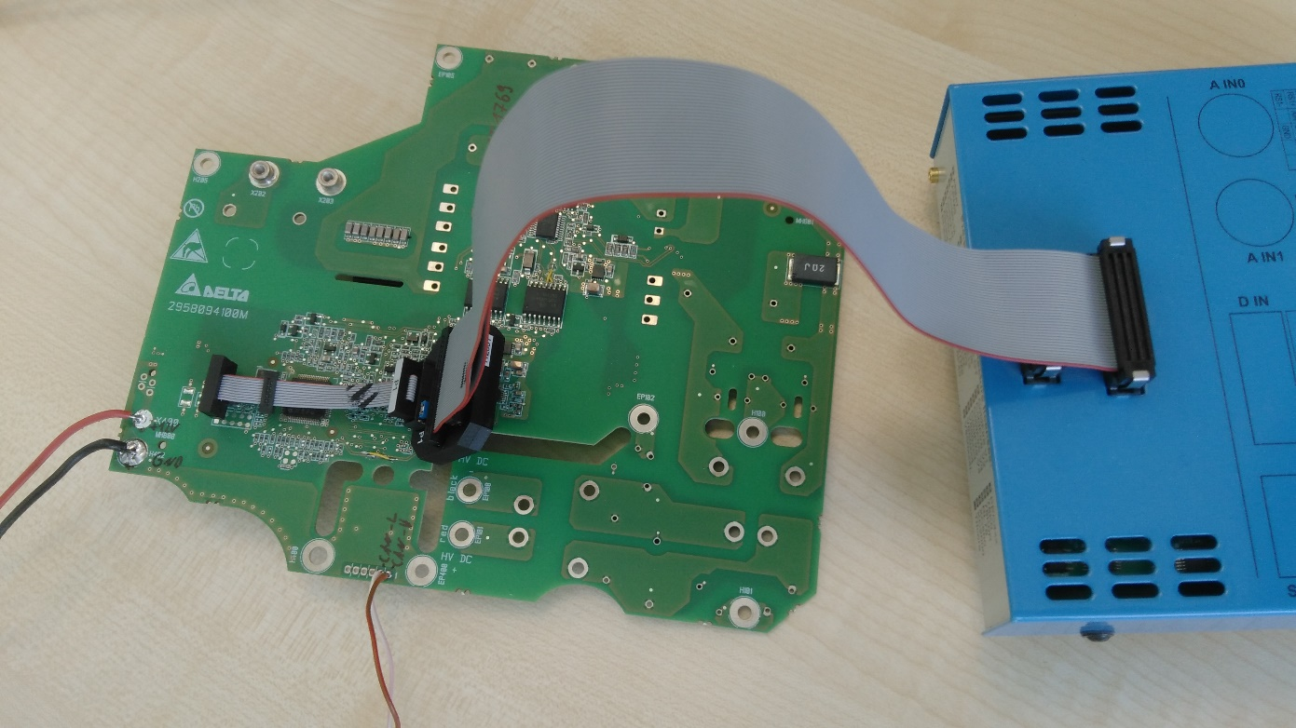

## program the HvController

* install MPLAB Tool.
* Connect ICD3 Connector to HV debugger Port
* Open MPLAB IPE and select Device PIC16F1769 .
* Select Hex File and click on Program

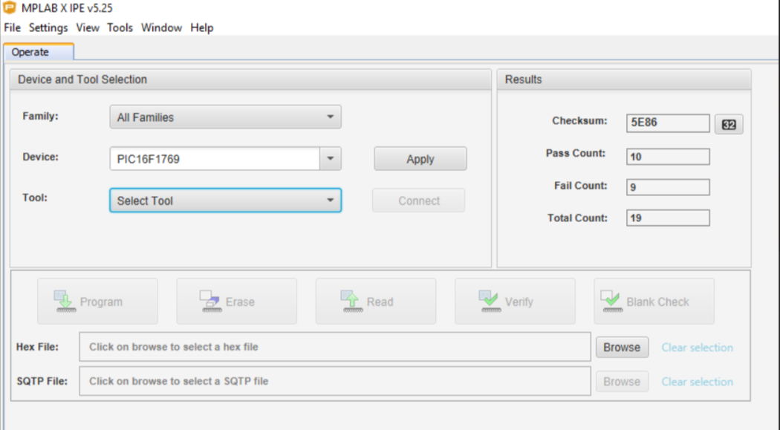

## How to Change the Version of Appl SW

* Change the Delta Sw Version marcos in ecuext_dcm.h file

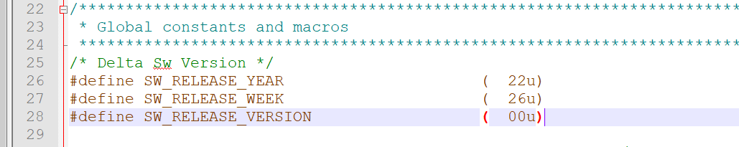

* Clean build and rebuild the project.

# How to create VflashPack for Application SW

* If you have no Python installed, please install python on you PC and set the python path to system variable on your PC.

Get install fine here T:\RnD_general\Tools\Python

Set path instruction:

Open System Properties (Right click Computer in the start menu, or use the keyboard shortcut Win+Pause)

Click Advanced system settings in the sidebar.

Click Environment Variables...

Select PATH in the System variables section

Click Edit

Add Python's path to the end of the list

* Please open the folder

https://desoeap16.delta.corp/svn/STEP1M_auto_renault/tags/Internal_Sw_Release/FBL_Tags/FBL_C1R6P2_DiagH/45_Appl_Tools/15_FlashContainer_DiagH

* copy the both HV and LV Hex file in input folder

/45_Appl_Tools/15_FlashContainer_DiagH/input

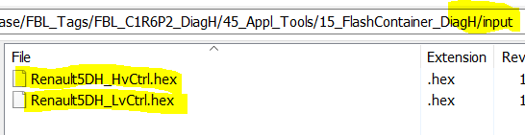

* Insert the correct application version and F012 DID data

Please open the file Info_5DH.txt add change only the marked values (line one and line eight).

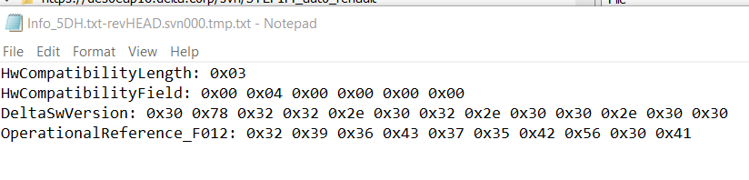

SwVersion: Year, Week, patch (this is supposed to be the customer identification of the SW)

DeltaSwVersion: Major, Minor, Patch, Test (this is supposed to be the Delta internal identification)

The others are expert settings, do not change. Save the changes.

* Run the file generate.bat.

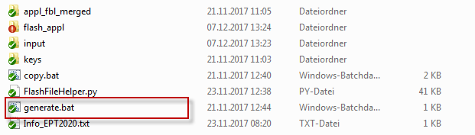

Result: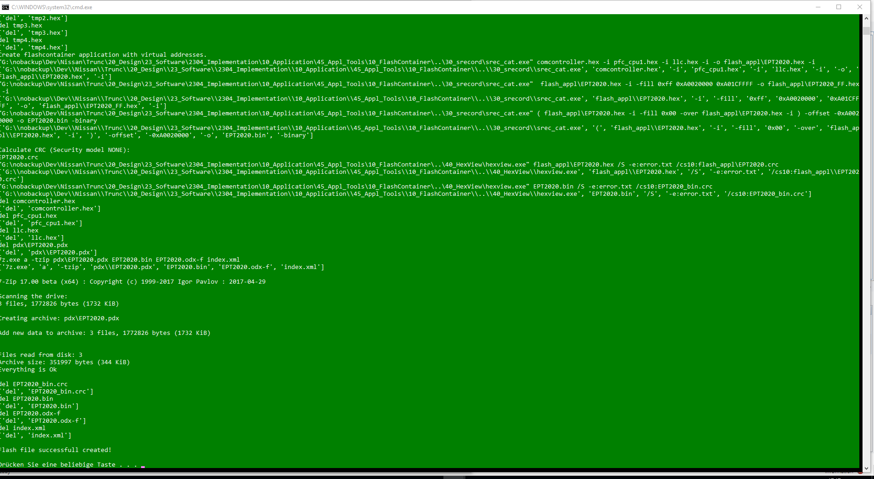

* Go to flash_appl fodler copy the 5DH_FF.hex into folder “15_FlashContainer_DiagH” and drag and drop on the “_generate_SHA_DemoKeys.bat” the output will be the signature as 256 Byte long and CRC.
* Now this signature together with 5DH_FF.hex will build the flash pack needed to flash the units

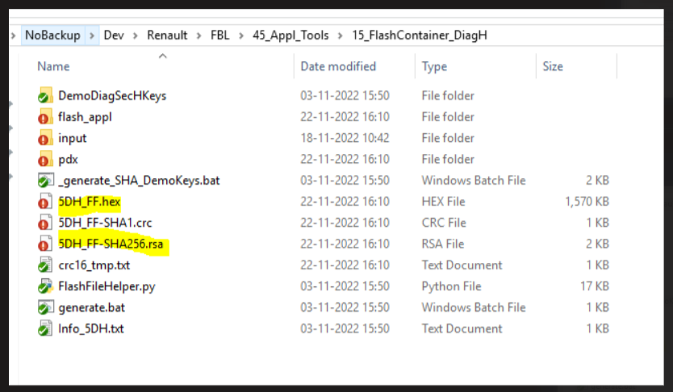

* Go to folder

<https://desoeap16.delta.corp/svn/STEP1M_auto_renault/branches/DES_SWEET400_FBL_Base_22_26_00/45_Appl_Tools/20_vFlashConfig>

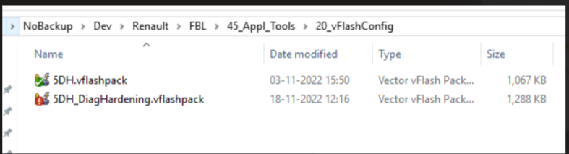

Open 5DH_DiagHardening.vflashpack with vFlash 7 SP3

* Select in the configure button the hex file 5DH_FF.hex and signature as in the picture below:

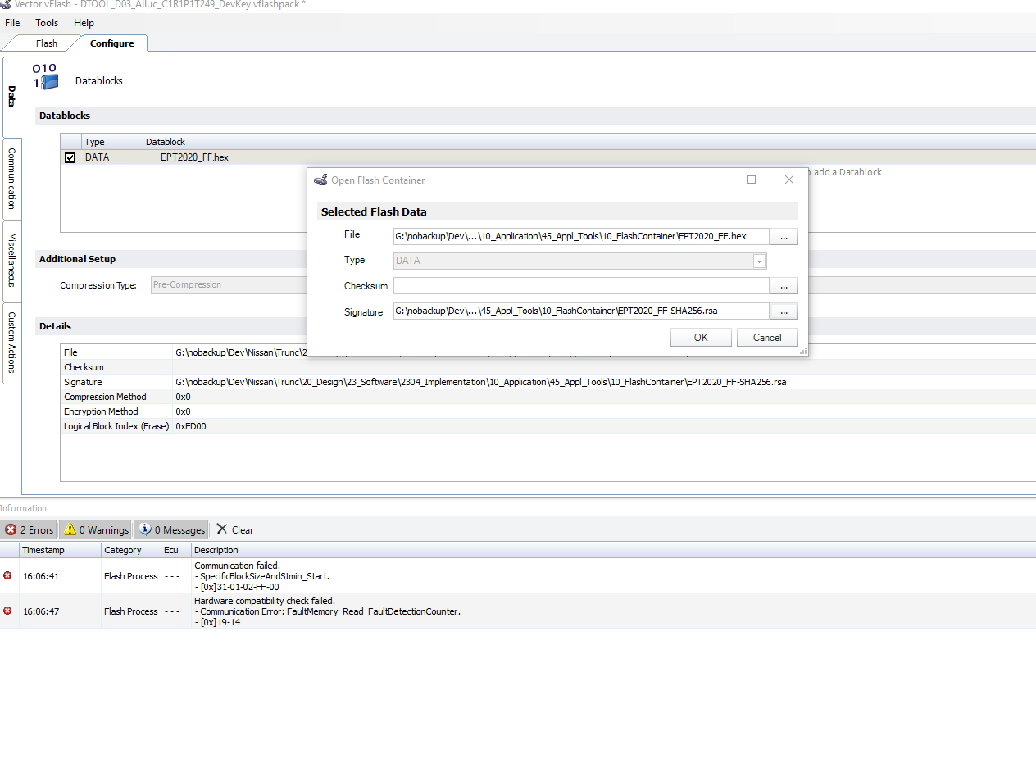

* Export project as Pack&Go.

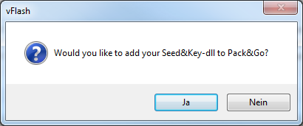

# How to create PDX

Open the “45_Appl_Tools/10_FlashContainer_DiagH”

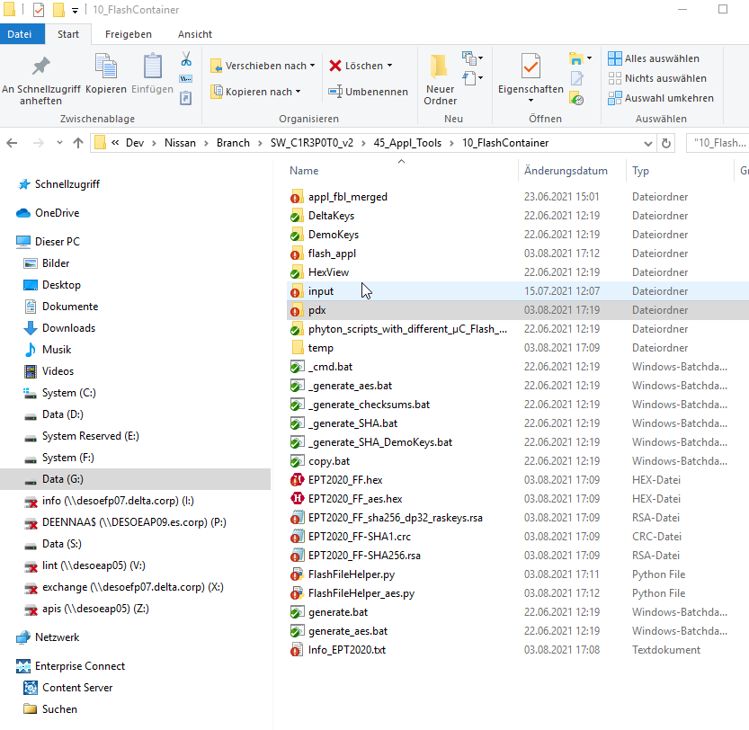

1. **Copy all application files to folder “/input” (manually)**
2. **Update the info file with the correct values for SW version and F012 DID and if needed also HWSW Compatibilty into Info_5DH.txt**
   1. 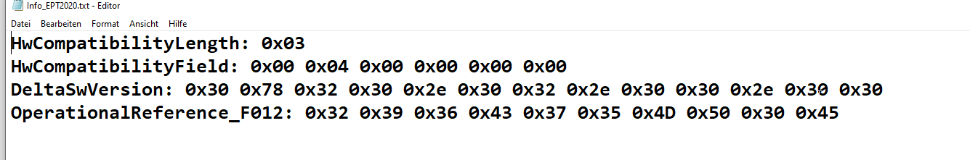
3. **Run the “generate.bat” this will merge the 3 applications in 1 hex file into folder “flash_appl”**
4. **Copy the merged hex “5DH_FF.hex ” from the “flash_appl” one folder up (to the current folder)**
5. **Drag it “5DH_FF.hex ” on the “_generate_SHA_DemoKeys.bat “ to generate the RSA Signature file**
6. **Copy the content of the “5DH_FF_sha256.rsa” without 0x and space into batch file “FlashFileHelper.py” (line 222) e.g.:**
   1. **Original signature: 0x83 ,0xAD ,0x34 ,0x64 ,0xB3 ,0x19 ,0xE9 ,0x08 ,0x7C ,0xCC ,0x44 ,0x86 ,0x48 ,0x02 ,0xBB ,0x0C ,0xE2 ,0x2C ,0x1D ,0x7B ,0x06 ,0xCE ,0x7B ,0x66 ,0xC8 ,0xC9 ,0xE3 ,0xE9 ,0x0C ,0xCF ,0xAA ,0x94 ,0x8B ,0xED ,0x2A ,0x32 ,0xCF ,0x1B ,0x49 ,0x88 ,0x68 ,0xDA ,0x3C ,0x54 ,0xB5 ,0xC7 ,0xA6 ,0x2A ,0xF7 ,0x23 ,0x74 ,0x9F ,0x1D ,0x53 ,0x42 ,0xCC ,0x4A ,0xCA ,0x51 ,0x87 ,0xBB ,0x06 ,0x29 ,0x3E ,0xFD ,0x4C ,0xE9 ,0x31 ,0xF1 ,0xE2 ,0x2A ,0x13 ,0xBD ,0x05 ,0xBC ,0xA6 ,0xA2 ,0x56 ,0xA0 ,0x05 ,0xEA ,0x58 ,0xB8 ,0x33 ,0xD4 ,0x4D ,0x17 ,0x9D ,0x79 ,0x18 ,0x7C ,0x7F ,0x24 ,0x61 ,0x86 ,0xDC ,0x53 ,0x3E ,0x89 ,0x84 ,0x92 ,0xEE ,0x55 ,0xAB ,0x17 ,0x69 ,0x6A ,0x20 ,0xE6 ,0xA0 ,0x97 ,0xB5 ,0xF0 ,0x41 ,0xFC ,0xAB ,0xE4 ,0xF9 ,0xD8 ,0x91 ,0x55 ,0x08 ,0x44 ,0x54 ,0xE2 ,0xF3 ,0xC1 ,0x43 ,0xD6 ,0x07 ,0x73 ,0x4D ,0x21 ,0x89 ,0x6E ,0x5E ,0xD4 ,0x45 ,0x34 ,0x8C ,0x97 ,0xC1 ,0x43 ,0x51 ,0xFE ,0x40 ,0xB3 ,0xF6 ,0x2B ,0x4C ,0x28 ,0x3A ,0x7A ,0xE5 ,0x35 ,0xDB ,0xE4 ,0x3F ,0x6E ,0xEB ,0x56 ,0xAB ,0x9B ,0x29 ,0x68 ,0x60 ,0x31 ,0xD7 ,0xAF ,0x8B ,0x5F ,0xA1 ,0xC3 ,0x61 ,0xAD ,0xB3 ,0x9C ,0x1B ,0x3F ,0x06 ,0x07 ,0x96 ,0x2F ,0xC6 ,0x38 ,0xED ,0x0F ,0x47 ,0x8E ,0x15 ,0x0D ,0x58 ,0xE7 ,0xE6 ,0x4E ,0x34 ,0xCB ,0x24 ,0x5F ,0x89 ,0x59 ,0xCB ,0x31 ,0x68 ,0x26 ,0x5A ,0xC2 ,0xE3 ,0xD9 ,0x16 ,0x24 ,0x09 ,0x05 ,0x71 ,0x8C ,0x5B ,0x4C ,0x88 ,0x4B ,0x51 ,0xCB ,0x0E ,0x73 ,0xD2 ,0x08 ,0x29 ,0x9C ,0x50 ,0x52 ,0x1F ,0x4D ,0x36 ,0xD0 ,0xAC ,0x18 ,0x16 ,0xDB ,0x0D ,0xA5 ,0x01 ,0x65 ,0xE8 ,0xAD ,0x04 ,0xCA ,0x33 ,0xEF ,0x34 ,0xCE ,0x4E ,0x11 ,0x9F ,0xC1 ,0xC9 ,0x8E ,0xE1**
   2. **After removal of space

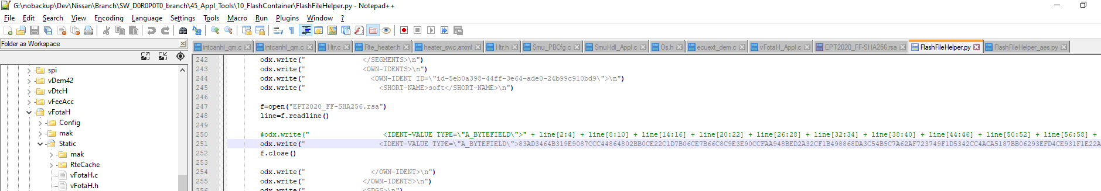

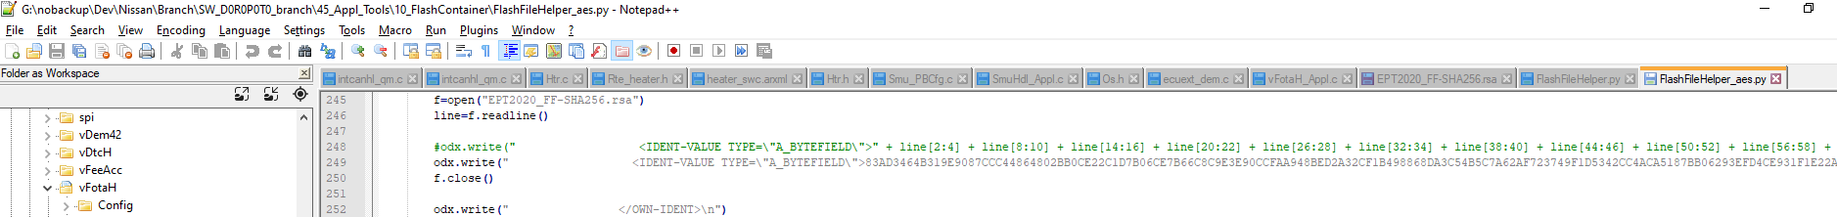

1. **Run the “generate.bat” to get the PDX into the pdx folder**

# “How to flash with vflash

After all controllers are programmed with the dedicated FBL and the *.vflashpack is created the SW can be flashed with the tool vFlash.

* + Take care that your PC has a valid licence for vFlash (either by dongle connection or with a CAN case that has the needed licence)
  + You need vFlash version 3.1
  + Ensure that the preconditions are ok to flash SW to OBC (UBat in range of 9 – 16V, AC voltage not connected, HVDC voltage not connected).
  + Do a reset of the OBC (either by UBat reconnection or by diagnostic service)
  + Take care that no “tester present” is send on the CAN by CanOe or other node.
  + Start vflash
  + Open released *.vflashpack file
  + Press flash

# Release the APPL SW

* Go to Below SVN path

https://desoeap16.delta.corp/svn/STEP1M_auto_renault/trunk/20_Design/23_Software/2307_Release

* Create New Release Folder in Internal/External folder

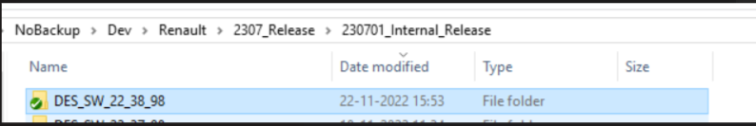

* Add candela, DBC, PDX, vflashpack, Vflash Hex and CRC, signature, file in created folder.

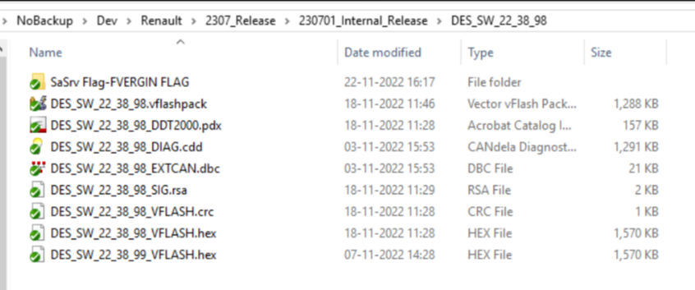

* One PDX file should be obtained when the SaSRV Mode value is "FNORMAL", the other when the value is "FVIRGIN". Then these two PDX files can be used in DDT2000 for DiagH testing.
* create New Folder in Created Release Folder with set SaSRV Flag to FVIRGIN
* Add candela, DBC, PDX, vflashpack, Vflash Hex and CRC, signature, file with set SaSRV Flag to FVIRGIN in created folder.

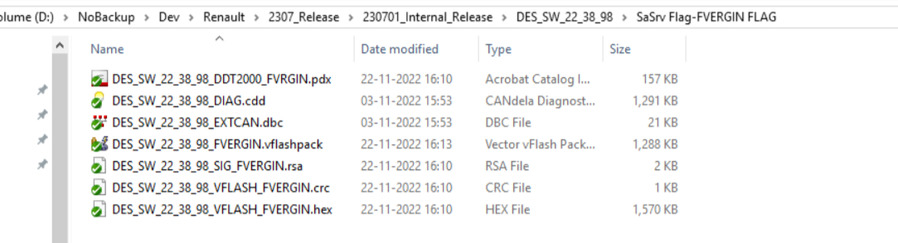

# How To Set SaSrv Mode To FVIRGIN

* Set SASRV_MODE to FVIRGIN The required change is in ApplDiag.c as shown below

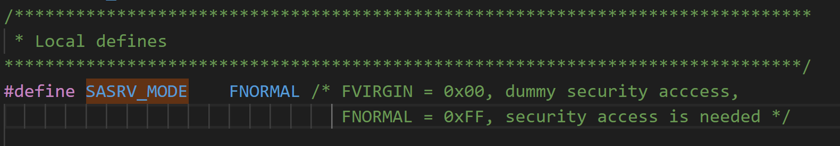

* Rebuild the project.
* Follow the same steps How to create VflashPack for Application SW
* Follow the same steps How to create PDX for Application SW

